Edit your personal besthealthquote.net website
View some examples first:
www.besthealthquote.net/rothrobertson
www.besthealthquote.net/lm
www.besthealthquote.net/tntinsurance
More Steps at the bottom of the document
Simple Steps:
- Login to your besthealthquote.net site
- If you don’t have the info email me ttropoloc@nia.biz
- Make sure your information is correct. And your agent # is the correct number at the end of the url’s that are associated with your carriers
- Scroll to the bottom to view the editing table.
- To upload an image click the image button
- Click browse server
- At the bottom select browse. Find the image you want to upload and select it. click open. Then click upload.
- Click browse server and select the image that you have uploaded.
- Click Ok.
- You can resize your image and select where you want it centered by clicking on it once. And selecing the center, left align, or right align, similar to whats found in Microsoft word. Then you can edit your text. When youre done click submit.
- Then click the link and view what your page looks like. You can edit it as many times as you want to get a perfect look for your page.
- Need more help? Contact me by e-mail ttropoloc@nia.biz or over the phone at 888-243-5026 ext. 108

Simple Steps:
- Login to your besthealthquote.net site
- If you don’t have the info email me ttropoloc@nia.biz
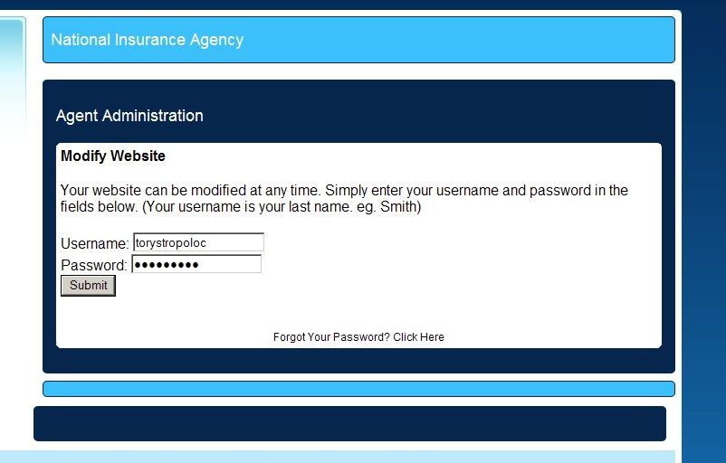

- Make sure your information is correct. And your agent # is the correct number at the end of the url’s that are associated with your carriers
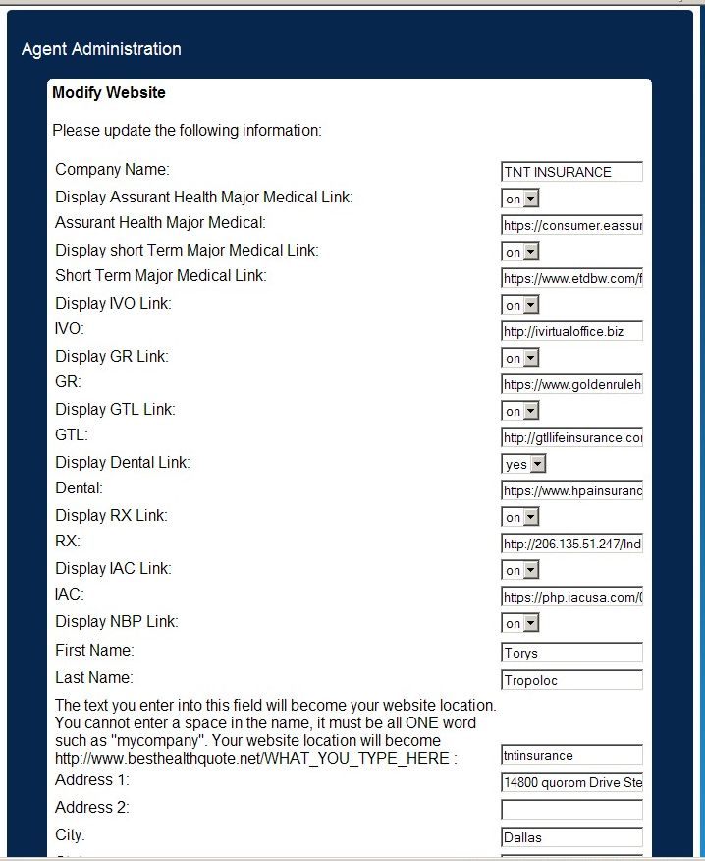
- Scroll to the bottom to view the editing table.
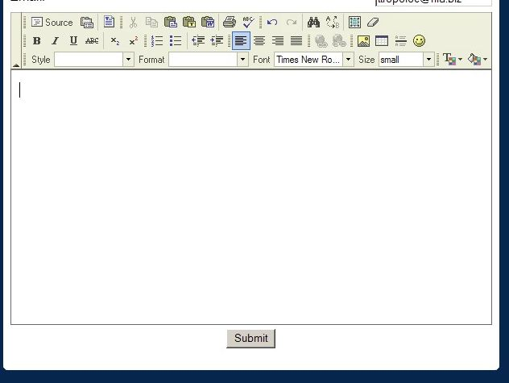

- To upload an image click the image button

- Click browse server
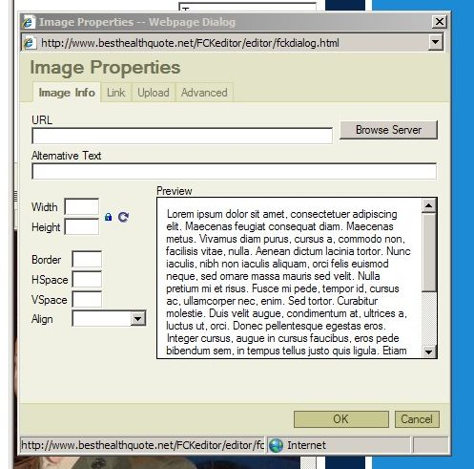

- At the bottom select browse. Find the image you want to upload and select it. click open. Then click upload.
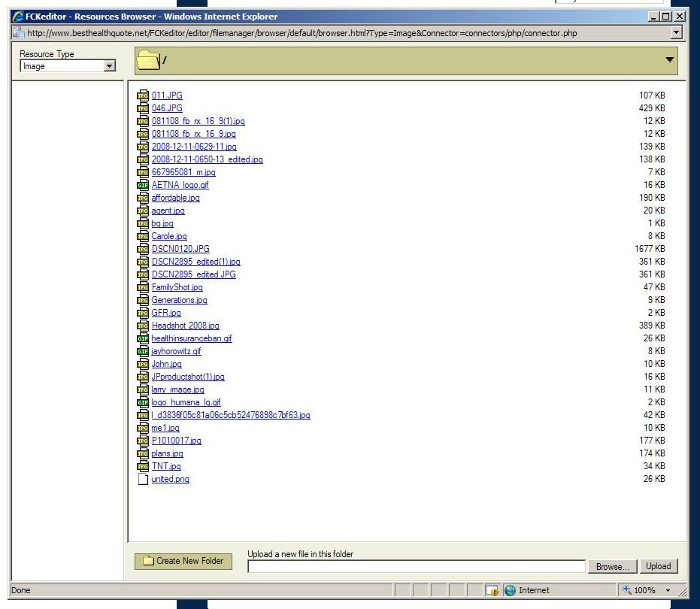

- Click browse server and select the image that you have uploaded.

- Click Ok.
- You can resize your image and select where you want it centered by clicking on it once. And selecing the center, left align, or right align, similar to whats found in Microsoft word. Then you can edit your text. When youre done click submit.
- Then click the link and view what your page looks like. You can edit it as many times as you want to get a perfect look for your page.
- Need more help? Contact me by e-mail ttropoloc@nia.biz or over the phone at 888-243-5026 ext. 108

